ــــــــــــــــــــــــــــ**Osama** Restaurant ـــــــــــــــــــــــــــــ



**System For Manage All Process in Restaurant**

**Tables**

* **Employee Tables :**
* **Employee_Table :**

All Employees In Restaurant Is Storage Here

Attribute :

* Id : int Primary Key
* FName : Varchar
* MName : Varchar
* LName : Varchar
* Status : tinyint
* Email : Varchar
* PhoenNumber : Varchar
* IdDepartment : int (Relation With Departments)
* Job_Id : Varchar
* Salary : Decimal
* StartDate : Date
* EndDate :Date
* Location : varchar
* Gender : tinyint
* **Departments:**

All Departments In Restaurant Is Storage Here

Attribute :

* Id : int Primary Key
* Name : Varchar
* **Managers:**

All Managers In Restaurant Is Storage Here

Attribute :

* Id : int Primary Key
* IdEmployee : int (Relation With Employee_Table)
* IdDepartment : int (Relation With Departments)
* **Chef_Table:**

All Chef Employees In Restaurant Is Storage Here

Attribute :

* Id : int Primary Key
* IdUser : int (Relation With Users_Table)
* IdCuisines: int (Relation With Cuisines_Table)
* Delivery_Table:
* **Delivery _Table:**

All Delivery Employees In Restaurant Is Storage Here

Attribute :

* Id : int Primary Key
* IdUser: int (Relation With Users_Table)
* Status: Bit
* **Users_Table:**

All Users Who Use System In Restaurant Is Storage Here

Attribute :

* Id : int Primary Key
* UserName: varchar
* Password: varchar
* IdEmployee : int (Relation With Employee_Table)
* Block : bit (For Block Or Unblock)
* **UserRoles_Table:**

Connect Users with There Roles

Attribute :

* Id : int Primary Key
* IdUser : int (Relation With Users_Table)
* IdRole: int (Relation With Roles_Table)
* **UserRoles_Table:**

All Roles In System

Attribute :

* Id : int Primary Key
* Name : varchar
* **Meals Table :**
* **Meals_Table:**

All Meals In Restaurant

Attribute :

* Id : int Primary Key
* Name : varchar
* Status : tinyint
* IdType: int (Relation With MealTypes)
* IdCuisines: int (Relation With Cuisines_Table)
* Descrption : varchar
* Price : Decimal
* Pricecost: Decimal
* **Offers:**

All Offers Of Meal In Restaurant

Attribute :

* Id : int Primary Key
* IdMeal: int (Relation With Meals_Table)
* Offer: decimal
* StartDate: Datetime
* EndDate: Detetime
* **MealTypes:**

All Type Of Meal In Restaurant

Attribute :

* Id : int Primary Key
* Title: varchar
* **Cuisines_Table:**

All Cuisines In Restaurant

Attribute :

* Id : int Primary Key
* Name: varchar
* **Sales Tables**
* **Sales_Table:**

All Orders In System

Attribute :

* Id : int Primary Key
* Number: int
* Price : decimal
* Pricecost : decimal
* IdMeal: int (Relation With Meals_Table)
* IdCustomer: int (Relation With Customers_Table)
* Date : Datetime Auto Renate by Date Now
* **Customers_Table:**

All Customers In System

Attribute :

* Id : int Primary Key
* FullName: Varchar
* Longitude: Float
* Latitude: float
* PhoneNumber: varchar(12)
* AddressDescription: varchar(1000)
* **Orders_Table:**

Status of Order(Log)

Attribute :

* Id : int Primary Key
* IdSales: int (Relation With Sales_Table)
* IdDelivery: int (Relation With Delivery_Table)
* Date : Datetime Auto Renate by Date Now
* Status: tinyint (Status Of Order (Waiting,Done, Cancel))
* Delivery_Locations:
* **Delivery_Locations :**

Locations of Any Delegate(Log Of Locations)

Attribute :

* Id : int Primary Key
* Longitude: Float
* Latitude: float
* IdDelivery: int (Relation With Delivery_Table)
* Date : Datetime Auto Renate by Date Now
* **Materials_Table**
* **Materials_Table:**

All Materials in Restaurant

Attribute :

* Id : int Primary Key
* Name: varchar
* **Orders_Materials_Table:**

Requests Of Material that were requested from the departments (Log Of Materials)

Attribute :

* Id : int Primary Key
* IdMaterials: int (Relation With Materials_Table)
* IdDepartment: int (Relation With Departments)
* IdUnit_Of_Measure_Table: int (Relation With Unit_Of_Measure_Table)
* Date : Datetime Auto Renate by Date Now
* Status: tinyint (Status Of Order (Done, Returne)))
* HowMany : float
* **Inventory_Table:**

Requests Of Material that were requested from the departments (Log Of Materials)

Attribute :

* Id : int Primary Key
* IdMaterials: int (Relation With Materials_Table)
* IdUnit_Of_Measure_Table: int (Relation With Unit_Of_Measure_Table)
* Date : Datetime Auto Renate by Date Now
* HowMany : float

**Procedure**

Employees :

To Add New Employee

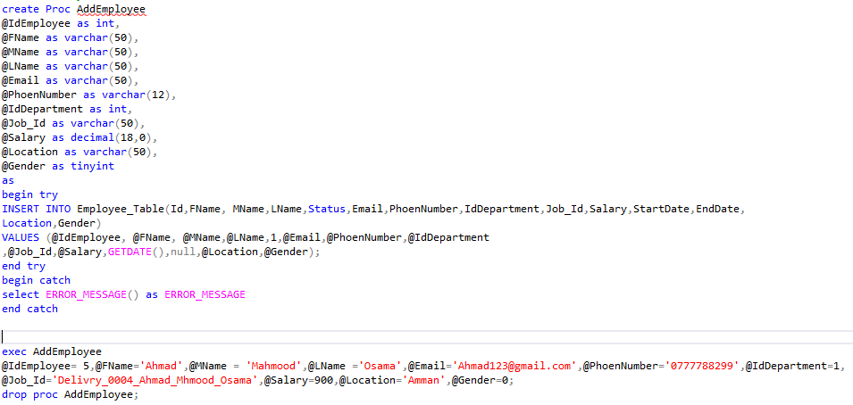

AddUser :

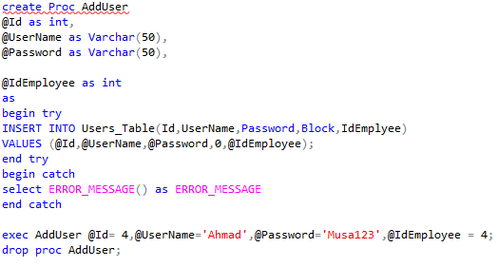

AddRoleUser:

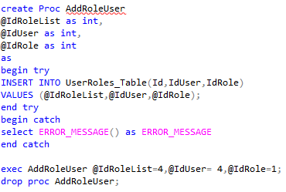

AddDelivry:

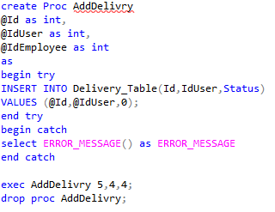

AddChef:

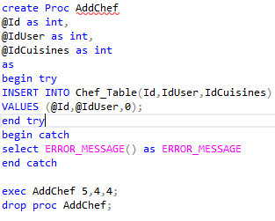

CRUD For Meal:

CreateMeal:

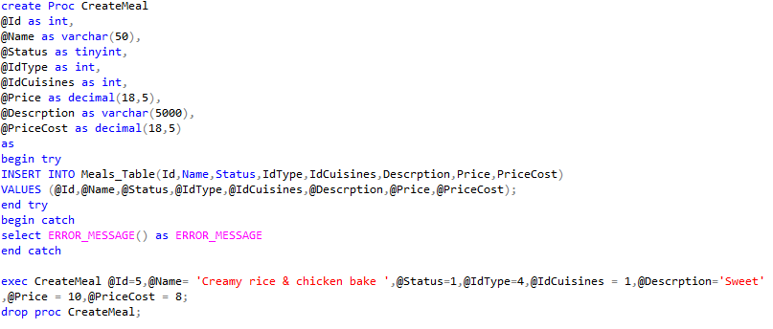

ReadByTypeMeal:

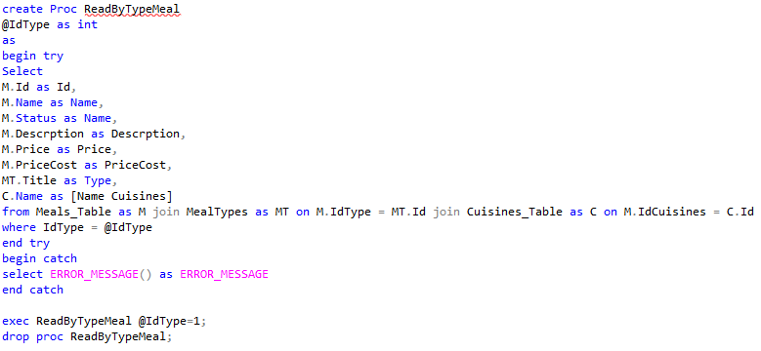

ReadByIdMeal:UpdateMeal:

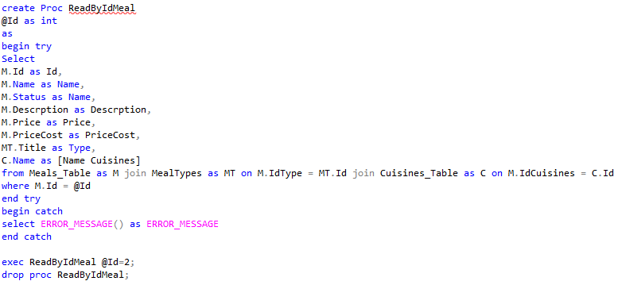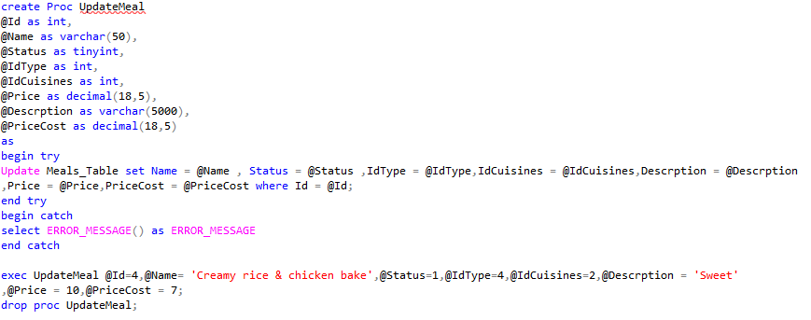

DeleteMeal:

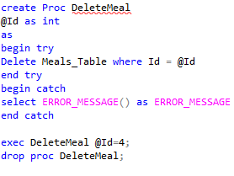

CRUD For Offers:

CreateOffers:

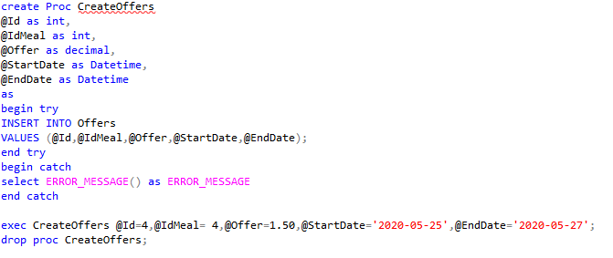

ReadByMealIdOffers:

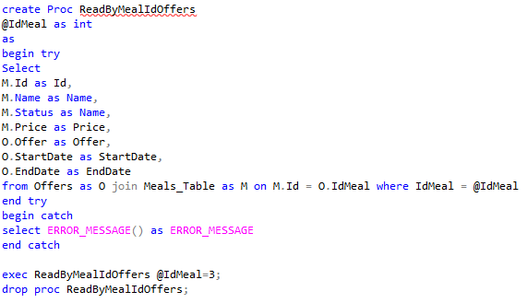

ReadByDateOffers:

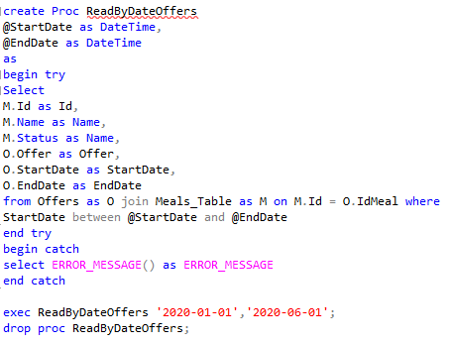

UpdateOffers:

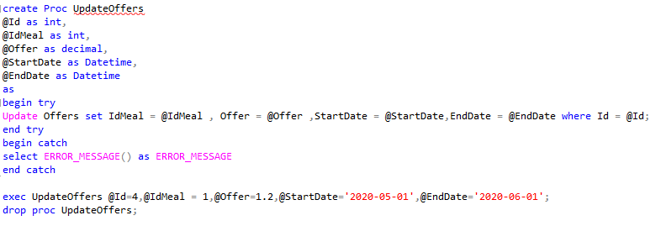

DeleteOffers:

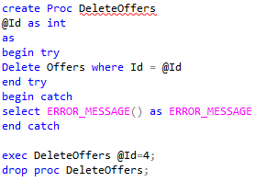

DisplayingMeals:

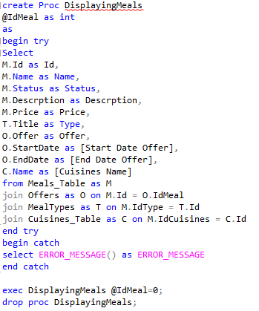

LogIn:

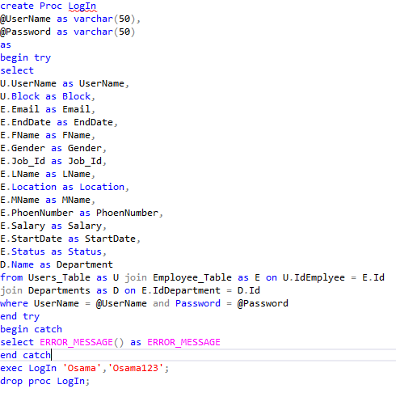

AddCustomer:

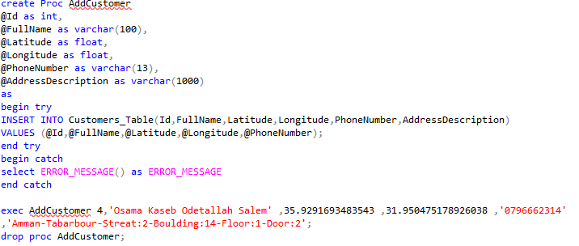

AddSales:

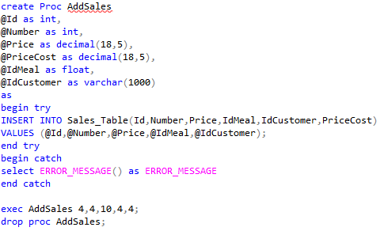

AddOrder:

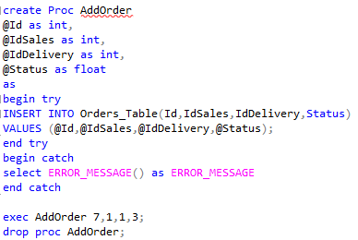

ReportsForExtractingTheNetProfit: 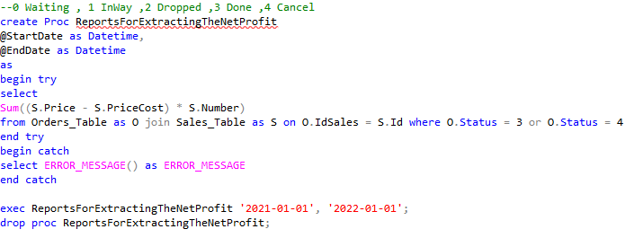

AddDeliveryLocations:

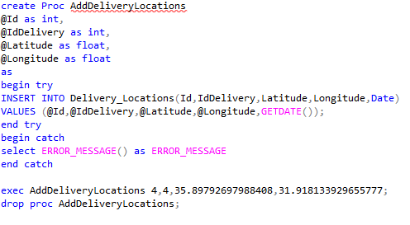

To Create Table With Default Date Time

